REGIONAL LANGUAGE QUESTION ANSWERING SYSTEM USING RETRIEVAL-AUGMENTED GENERATION AND LARGE LANGUAGE MODELS
PHASE I REPORT
Submitted by
KABILESH P 230701133
MADHUMITHA P 230701169
MANIKANDAN M 230701174
MANISHAA G 230701176

in partial fulfillment for the award of the degree
of
BACHELOR OF ENGINEERING
IN


COMPUTER SCIENCE AND ENGINEERING

RAJALAKSHMI ENGINEERING COLLEGE, CHENNAI ANNA UNIVERSITY: CHENNAI 600 025

OCTOBER 2026

Certified that this report "REGIONAL LANGUAGE QUESTION ANSWERING SYSTEM USING RETRIEVAL-AUGMENTED GENERATION AND LARGE LANGUAGE MODELS" is the bonafide work of KABILESH P (230701133), MADHUMITHA P (230701169), MANIKANDAN M (230701174) and MANISHAA G (230701176) who carried out the project work under my supervision. Certified further that, to the best of my knowledge, the work reported herein does not form part of any other thesis or dissertation on the basis of which a degree or award was conferred on an earlier occasion on this or any other candidates.
This project addresses the following Sustainable Development Goal(s):
Goal No: 4 – Quality Education Goal No: 9 – Industry, Innovation and Infrastructure
Goal No: 10 – Reduced Inequalities Goal No: 16 – Peace, Justice and Strong Institutions

SIGNATURE  Dr. J. Manoranjini , M.E., Ph.D.,  Professor and Head,  Department of Computer Science and Engineering,  Rajalakshmi Engineering College, Chennai – 602 105. | SIGNATURE  Dr. Chettiyar Vani. V, M.E., Ph.D.,  Professor,  Department of Computer Science and Engineering,  Rajalakshmi Engineering College, Chennai – 602 105.
Submitted to Project Viva-Voce examination held on ______________

Internal Examiner | External Examiner

ABSTRACT

Access to reliable information in Indian regional languages remains challenging because of linguistic diversity, limited language-specific resources, and the difficulty of obtaining document-grounded answers. This project presents DesiQuery, a multilingual Retrieval-Augmented Generation (RAG) system for document-based question answering across eight Indian languages. The system accepts PDF, TXT, and DOCX documents, extracts and processes their textual content, divides the content into retrievable chunks, and generates multilingual embeddings using BAAI/bge-m3, which are stored in ChromaDB for semantic retrieval. When a user submits a question, the system retrieves relevant content and applies context selection before passing the evidence to Llama 3 through Ollama for local response generation. The generated response is constrained to the retrieved document evidence and the selected output language, while also retaining source-document, page, chunk, and similarity information for transparency. The system is implemented using React and FastAPI and operates without dependence on cloud-based LLM APIs. An evaluation of 24 test cases across eight languages resulted in 19 PASS, 5 WARNING, and 0 FAIL cases, validating language accuracy, grounding, and source traceability. The results demonstrate the feasibility of a local, document-grounded multilingual QA system while highlighting response completeness and local inference latency as areas for further improvement.

ACKNOWLEDGEMENT
Initially we thank the Almighty for being with us through every walk of our life and showering his blessings through the endeavor to put forth this report. Our sincere thanks to our Chairman Mr. S. MEGANATHAN, B.E, F.I.E., our Vice Chairman Mr. ABHAY SHANKAR MEGANATHAN, B.E., M.S., and our respected Chairperson Dr. (Mrs.) THANGAM MEGANATHAN, Ph.D., for providing us with the requisite infrastructure and sincere endeavoring in educating us in their premier institution.
Our sincere thanks to Dr. S.N. MURUGESAN, M.E., Ph.D., our beloved Principal for his kind support and facilities provided to complete our work in time. We express our sincere thanks to Dr. J. MANORANJINI, M.E., Ph.D., Professor and Head of the Department of Computer Science and Engineering for her guidance and encouragement throughout the project work. We convey our sincere and deepest gratitude to our internal guide, Dr. CHETTIYAR VANI VIVEKANAND, M.E., Ph.D., Professor, Department of Computer Science and Engineering for her valuable guidance throughout the course of the project. We thank our Project Coordinator, Dr. MADHUSUDHANAN , Ph.D., Associate Professor, Department of Computer Science and Engineering for his valuable guidance during our review to build our project.

KABILESH P : 230701133
MADHUMITHA P : 230701169
MANIKANDAN M : 230701174
MANISHAA G : 230701176

TABLE OF CONTENTS
Chapter No. | Title | Page No.
 | ABSTRACT | iii
 | LIST OF TABLES | vii
 | LIST OF FIGURES | viii
 | LIST OF ABBREVIATIONS | ix
1 | INTRODUCTION | 1
 | 1.1 General | 1
 | 1.2 Objectives | 2
 | 1.3 Existing System | 3
 | 1.4 Proposed System | 4
2 | LITERATURE SURVEY | 6
 | 2.1 Literature Review | 6
 | 2.2 Comparison and Discussion | 14
 | 2.3 Conclusion | 15
3 | SYSTEM DESIGN | 17
 | 3.1 System Architecture | 17
 | 3.2 System Components | 20
 | 3.3 Document Preprocessing and Chunking | 21
 | 3.4 Query Processing and Embedding Generation | 22
 | 3.5 Vector Indexing and Semantic Retrieval | 23
 | 3.6 Context Augmentation and Response Generation | 23
4 | PROJECT DESCRIPTION | 24
 | 4.1 Introduction | 24
 | 4.2 Document Processing Module | 24
 | 4.3 Language Processing and Normalization Module | 25
 | 4.4 Embedding and Vector Storage Module | 26
 | 4.5 Semantic Retrieval Module | 26
 | 4.6 Response Generation Module | 27
 | 4.7 User Interface Module | 27
 | 4.8 Summary | 28
5 | IMPLEMENTATION AND RESULTS | 29
 | 5.1 Introduction | 29
 | 5.2 Implementation Details | 29
 | 5.3 System Execution | 35
 | 5.4 Result Analysis | 37
 | 5.5 Discussion | 40
 | 5.6 Summary | 41
6 | CONCLUSION AND FUTURE WORK | 42
 | 6.1 Conclusion | 42
 | 6.2 Future Work | 43
 | REFERENCES | 47

LIST OF TABLES
TABLE NO. | TABLE NAME | PAGE NO.
5.1 | Overall Evaluation Results | 38
5.2 | Language-wise Evaluation Results | 39

LIST OF FIGURES
FIGURE NO. | FIGURE NAME | PAGE NO.
1.1 | Overview of the Proposed system | 5
3.1 | Architecture of the Proposed system | 19
4.1 | Document Processing Module | 25
4.2 | Language Processing and Normalization Module | 25
4.3 | Embedding and Vector Storage Module | 26
4.4 | Semantic Retrieval Module | 27
4.5 | Response Generation Module | 27
5.1 | Dashboard Interface | 30
5.2 | Document Upload and Management Interface | 31
5.3 | Multilingual Question Answering Interface | 32
5.4 | Generated Answer with Source Attribution | 33
5.5 | Retrieved Evidence and AI Pipeline | 34
5.6 | Document Analyzer Interface | 35
5.7 | System Execution Flow | 37

LIST OF ABBREVIATIONS
RAG | Retrieval-Augmented Generation
LLM | Large Language Model
QA | Question Answering
NLP | Natural Language Processing
IR | Information Retrieval
IndicNLP | Indic Natural Language Processing (library for Indian languages)
ChromaDB | Open-source vector database used for semantic retrieval
API | Application Programming Interface
FastAPI | Python web framework used for backend services
BGE-M3 | Multilingual dense embedding model used for vectorisation
Top-K | The K highest-ranked retrieved results for a query
d | Dimensionality of an embedding vector
S(q, v) | Cosine similarity between query vector q and chunk vector v
Wsize | Chunking window size
Woverlap | Chunking window overlap

CHAPTER 1

INTRODUCTION

1.1 GENERAL
The rapid growth of digital information has made question answering (QA) systems an essential tool for accessing knowledge efficiently. However, most existing QA systems are designed primarily for the English language, which creates a significant barrier for users who communicate in Indian regional languages. India is linguistically diverse, with multiple languages differing in script, vocabulary, and grammatical structure, making it difficult to directly apply standard QA systems.
Recent advancements in Large Language Models (LLMs) have improved the ability of machines to understand and generate human language. Despite their success, these models often produce responses that are not factually accurate or are not supported by reliable sources, especially when dealing with domain-specific queries. This issue, commonly referred to as hallucination, reduces the reliability of such systems.
To address these limitations, Retrieval-Augmented Generation (RAG) has emerged as an effective approach. It combines document retrieval with language generation, ensuring that responses are based on actual information rather than purely on learned patterns. This project leverages RAG along with regional language processing techniques to build a system capable of providing accurate, document-based answers.
The proposed system integrates multilingual processing, semantic search, and local large language models to support regional language queries. By grounding responses in a controlled knowledge base, the system aims to improve accessibility, reliability, and usability for users who prefer Indian regional languages.

1.2 OBJECTIVES OF THE PROJECT

The primary objective of this project is to develop a multilingual, document-grounded question answering system capable of supporting multiple Indian languages. The system is designed to process documents in PDF, TXT, and DOCX formats by extracting and preprocessing textual content, followed by IndicNLP-based normalization to effectively handle regional language variations. It generates multilingual embeddings using the BAAI/bge-m3 model and stores them in ChromaDB to enable efficient semantic retrieval of relevant information. Based on user queries, the system retrieves contextually appropriate document segments and applies context selection before generating accurate, evidence-based responses using Llama 3 through Ollama. Additionally, the system ensures transparency by providing source traceability, including document references and similarity details, and is implemented using a React frontend and FastAPI backend. The entire pipeline is designed to operate locally without reliance on cloud-based LLM APIs, ensuring privacy, control, and offline usability.

1.3 EXISTING SYSTEM
Existing question answering systems are predominantly designed for English and rely heavily on pre-trained language models. These systems often fail to perform effectively when handling regional languages due to limited training data and lack of language-specific processing techniques. As a result, users who communicate in Indian languages face difficulties in accessing accurate information.
Many traditional QA systems depend entirely on large language models without incorporating external knowledge sources. This leads to the problem of hallucination, where the system generates answers that may sound correct but are not supported by any real data. Such responses can be misleading, especially in critical domains like government schemes and official documents.
Another limitation of existing systems is their inability to process document-based queries efficiently. Most systems do not provide mechanisms for uploading and searching within custom documents, which restricts their usefulness in real-world applications where information is often stored in document form.
Furthermore, existing solutions generally lack support for offline or local deployment. They depend on cloud-based services, raising concerns about data privacy, internet dependency, and system latency. These limitations highlight the need for a more reliable and regionally adaptable solution.

1.4 PROPOSED SYSTEM
The proposed DesiQuery system is a multilingual document-grounded question answering application designed to provide information from selected document sources. The system supports PDF, TXT, and DOCX documents and allows users to select existing documents or upload new documents before submitting a question.
During document processing, the system extracts the available textual content from the uploaded documents. For Indian regional-language content, IndicNLP-based normalization is applied to prepare the extracted text for subsequent processing. The normalized content is then divided into smaller retrievable chunks.
Each document chunk is converted into a multilingual vector representation using BAAI/bge-m3. The generated embeddings, together with the associated document metadata, are stored in ChromaDB.
When a user submits a question, the query is processed and normalized using the language-processing stage and converted into a multilingual embedding using BAAI/bge-m3. ChromaDB performs semantic retrieval using cosine-based similarity and identifies the most relevant document chunks from the selected knowledge sources.
The retrieved chunks are passed through a context-selection stage. Relevant evidence is retained while redundant or weakly related content may be reduced before response generation.
The selected evidence is supplied to Llama 3 through Ollama for local response generation. The generation process is instructed to use the retrieved document evidence and produce the response in the selected output language. If the required information cannot be identified in the retrieved evidence, the system indicates that the information is unavailable.
The system also retains source-document, page number when available, chunk identifier, and similarity information associated with the retrieved evidence. This information is returned to the frontend so that users can inspect the document evidence associated with an answer.
The system is implemented using React and FastAPI and supports local execution of the core question answering pipeline without dependence on cloud-based LLM APIs.
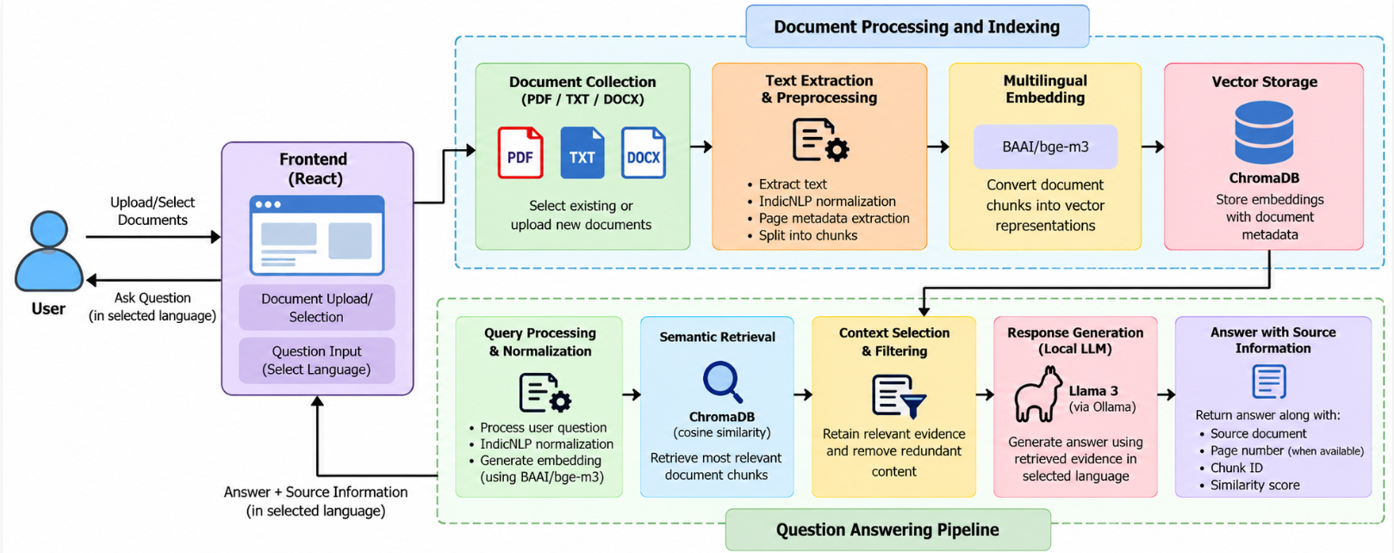
Figure 1.1: Overview of the Proposed System

CHAPTER 2

LITERATURE SURVEY
This section of the paper, provides an all-round review about multiple existing systems that holds similar objective and problem statements as that of the proposed project. The study of these existing papers will produce valuable insights for the construction of the proposed system.

2.1 LITERATURE REVIEW
The paper (Khan et al., 2026), titled “UQA-RAG: Enhancing Urdu Question-Answer Retrieval with Semantic Similarity and LLMs,” discusses the application of Retrieval-Augmented Generation for question answering in the Urdu language. The proposed UQA-RAG approach combines dense semantic retrieval using embeddings and ChromaDB with lexical retrieval using BM25. The combination of semantic and lexical retrieval helps the system identify relevant information from the available knowledge sources before generating an answer. The work demonstrates the potential of RAG-based approaches for low-resource languages such as Urdu. However, the effectiveness of the approach is dependent on the availability of suitable language-specific resources and the quality of the retrieved information.
The paper (Nadǎs, Diosan, and Tomescu, 2025), titled “Synthetic Data Generation Using Large Language Models: Advances in Text and Code,” presents a survey of synthetic data generation using Large Language Models through prompting, self-instruction, and Retrieval-Augmented Generation techniques. The paper discusses the usefulness of synthetic data for applications such as question answering, especially in situations where sufficient real-world training data is unavailable. The study also highlights important challenges associated with synthetic data generation, including factuality, bias, and reliability. Although synthetic data can help increase the amount of available training information, the quality and correctness of the generated data must be carefully evaluated before using it for QA applications.
The paper (de Oliveira and Cerqueira, 2026), titled “Resource Constrained Evaluation of Quantized Local LLMs for Retrieval-Augmented Generation on a Reduced-Corpus Setting,” investigates the performance of locally deployed quantized Large Language Models under resource-constrained RAG environments. The study evaluates different aspects such as retrieval quality, answer quality, latency, and runtime failures. The results indicate that larger language models do not necessarily provide better performance for every RAG application. The study highlights the importance of selecting models according to computational resources, retrieval requirements, and application constraints. This work demonstrates that efficient and smaller models can also be considered for practical RAG-based systems under limited-resource environments.
The paper (Onan et al., 2026), titled “Comparing ChatGPT, Gemini, and Emerging LLMs in Low-Resource Educational Settings: Reasoning Quality, Consistency, and Explainability,” evaluates the performance of Large Language Models for educational question answering in low-resource language settings. The study considers different factors such as accuracy, reasoning quality, consistency, and explainability. The research highlights that the performance of LLMs can vary across different languages and that models developed primarily using high-resource languages may not provide the same level of performance for low-resource languages. The study emphasizes the importance of evaluating reasoning and consistency along with simple answer accuracy for multilingual educational QA systems.
The paper (Perevalov et al., 2025), titled “SPARQL Query Candidate Filtering for Improving the Quality of Multilingual Question Answering over Knowledge Graphs Using Language Models,” investigates multilingual question answering over knowledge graphs using language-model-based SPARQL query filtering. The proposed approach focuses on filtering candidate SPARQL queries so that the most relevant query can be selected for answering a user's question. The study explores the use of language models to improve the interaction between natural language questions and structured knowledge graphs across multiple languages. The work demonstrates the potential of combining knowledge graphs and language models for multilingual QA, while also highlighting the challenges associated with language-specific query processing and knowledge representation.
The paper (Sinthusha, Charles, and Weerasinghe, 2025), titled “Machine Reading Comprehension for the Tamil Language with Translated SQuAD,” focuses on developing a machine reading comprehension dataset for the Tamil language by translating the SQuAD dataset. The study evaluates multilingual transformer models on the translated Tamil dataset and introduces an answer start correction method to address word-order issues caused during translation. The authors also highlight that conventional answer evaluation metrics may not be completely suitable for Tamil because of its agglutinative linguistic structure. The study therefore emphasizes the importance of language-specific preprocessing and evaluation methods when developing question answering systems for Tamil and other Indian regional languages.
The paper (Amal, Niranjan, and Thushara, 2026), titled “EduRAG: A Multimodal Explainable RAG System with Deterministic Token Grounding,” proposes a Retrieval-Augmented Generation approach for educational question answering. The system combines lexical and dense retrieval methods along with query expansion and re-ranking to improve the retrieval of relevant information. It also incorporates a vision-language model and evidence attribution mechanisms to improve explainability and provide supporting evidence for generated answers. The approach demonstrates how multiple retrieval and reasoning components can be combined to improve the reliability of educational QA systems. However, the integration of multiple modules can increase the complexity and computational requirements of the overall system.
The paper (Behmanesh et al., 2024), titled “A Novel Open-Domain Question Answering System on Curated and Extracted Knowledge Bases with Consideration of Confidence Scores in Existing Triples,” presents an open-domain question answering system based on curated and extracted knowledge bases. The approach incorporates confidence scores associated with knowledge-base triples to improve answer selection and ranking. The use of confidence information helps the system determine the reliability of available knowledge before generating an answer. The study demonstrates the importance of knowledge curation and confidence-aware answer ranking in open-domain QA. However, the retrieval performance decreases when queries become complex and contain multiple entities, showing that handling complex questions remains a challenge.
The paper (Liao, Lee, and Wang, 2026), titled “Cross-Attention Reprogramming for ASR: Bridging Discrete Speech Units and Pretrained Language Models,” investigates cross-attention reprogramming techniques for improving the interaction between speech representations and pretrained language models. The approach enables pretrained language models to process representations obtained from another modality and supports low-resource and cross-lingual scenarios. The work demonstrates the potential of adapting existing pretrained language models rather than developing completely new models for every application. The study is particularly relevant to multilingual and low-resource environments, although the effectiveness of the approach depends on the quality of the available representations and the target language resources.
The paper (Choi et al., 2025), titled “Toward Generating Quality Test Questions and Answers Using Quantized Low-Rank Adapters in LLMs,” investigates the use of Quantized Low-Rank Adaptation for generating questions and answers using Large Language Models. The study demonstrates how QLoRA can be used to adapt models for task-specific question and answer generation while reducing the computational requirements associated with traditional fine-tuning. The approach provides a resource-efficient method for adapting large language models to specific QA tasks. However, the performance of the system still depends on the availability of suitable training data from the target domain.
The paper (Huang and Su, 2025), titled “TransAlignNet: Semantic Consistency Learning with Multi-Modal Attention for English Translation Inference,” focuses on improving semantic consistency in multilingual translation-related tasks. The study investigates the use of multi-modal attention mechanisms to preserve the semantic relationship between source and translated information. Maintaining semantic consistency is important in multilingual question answering because translation can introduce changes in word order, meaning, or contextual relationships. The work therefore highlights the importance of preserving semantic information when language models process multilingual content and demonstrates the need for language-aware approaches in cross-lingual NLP applications.
The paper (Ijebu et al., 2025), titled “Ensemble Answer Selection Leveraging Cross-Lingual Dealignment for Improved QA with Mixture-of-Experts Setup,” proposes an ensemble-based approach for answer selection in multilingual question answering. The system utilizes cross-lingual dealignment and a mixture-of-experts setup to improve the selection of appropriate answers across different languages. The ensemble architecture allows multiple models or experts to contribute to the final answer selection process. The study demonstrates the potential of combining different model capabilities for multilingual extractive QA. However, multilingual systems still face challenges due to differences in linguistic structures, available datasets, and resource availability between languages.
The paper (Hambarde and Proença, 2023), titled “Information Retrieval: Recent Advances and Beyond,” presents an analysis of recent developments in information retrieval techniques, including sparse retrieval, dense retrieval, hybrid retrieval, and second-stage ranking methodologies. The study emphasizes that information retrieval is a critical component of modern question answering systems because the quality of the retrieved information directly affects the quality of the generated response. The authors highlight that retrieval should be optimized before the generation stage in RAG systems. The study therefore establishes retrieval quality as an important factor in developing reliable question answering systems and indicates that combining different retrieval strategies can improve the overall retrieval process.
The paper (Fields, Chovanec, and Madiraju, 2024), titled “A Survey of Text Classification with Transformers: How Wide? How Large? How Long? How Accurate? How Expensive? How Safe?” examines the performance of transformer-based models for text classification and analyzes the relationship between model size, accuracy, computational cost, and safety. The study demonstrates that increasing the size of a language model does not always result in better performance for every natural language processing task. The work highlights the importance of selecting models according to the specific task requirements rather than relying only on model size. These findings are relevant to multilingual QA systems where computational resources, language characteristics, and task-specific performance need to be considered together.
The paper (Hu et al., 2024), titled “Prompting Large Language Models with Knowledge-Injection for Knowledge-Based Visual Question Answering,” investigates the use of knowledge injection to improve knowledge-based visual question answering. The approach provides additional background knowledge to the language model so that it can use external information while answering questions. The study demonstrates that knowledge injection can improve the ability of a model to reason over information that may not be directly available in the input. However, the injected knowledge itself may not always be grounded or reliable. Therefore, the study highlights the importance of verifying external knowledge before incorporating it into the answer generation process.
The paper (Xu et al., 2024), titled “ChattF: A Knowledge Graph-Enhanced Intelligent Q&A System for Mitigating Factuality Hallucinations in Traditional Folklore,” proposes a knowledge graph-enhanced question answering system for traditional folklore. The system integrates knowledge graph-based retrieval into a RAG framework to provide supporting information for answer generation. The use of a structured knowledge graph helps the system retrieve factual information before generating an answer and aims to reduce hallucinations. However, the performance of the system depends strongly on the completeness and quality of the knowledge graph. Missing or incomplete information in the knowledge graph can therefore affect the quality of the final answer.
The paper (Saha, Saha, and Malik, 2024), titled “QuIM-RAG: Advancing Retrieval Augmented Generation with Inverted Question Matching for Enhanced QA Performance,” proposes a Retrieval-Augmented Generation framework based on inverted question matching. The approach generates hypothetical questions from document fragments to improve the relationship between user queries and the information stored in documents. By associating document fragments with potential questions, the system attempts to improve the retrieval of relevant information during the question answering process. The work demonstrates the potential of question-oriented document processing for improving retrieval performance and provides an approach for strengthening the connection between user queries and retrieved document content.
The paper (Kong et al., 2025), titled “Multi-Perspective Consistency Checking for Large Language Model Hallucination Detection: A Black-Box Zero-Resource Approach,” proposes a multi-perspective consistency checking method for detecting hallucinations in Large Language Models. The approach examines generated responses from different perspectives to identify inconsistencies that may indicate unreliable or hallucinated information. The study highlights the importance of consistency checking because fluent language model responses may still contain unsupported information. The proposed approach demonstrates the need for additional reliability mechanisms in LLM-based question answering systems, particularly when factual correctness is important.
The paper (Ali et al., 2025), titled “Multilingual Relation Extraction: A Survey,” provides a survey of multilingual relation extraction and discusses challenges associated with multilingual natural language processing. The study identifies resource imbalance and reproducibility as important challenges in multilingual NLP. Different languages have different amounts of annotated datasets, pretrained resources, and available computational support, which can lead to differences in model performance. The findings are relevant to multilingual question answering because the availability and quality of language-specific resources directly affect information retrieval, language understanding, and answer generation.
The paper (Hindi et al., 2025), titled “Enhancing the Precision and Interpretability of Retrieval-Augmented Generation (RAG) in Legal Technology: A Survey,” investigates the application of Retrieval-Augmented Generation in the legal technology domain. The study discusses important challenges associated with retrieval, hallucination, faithfulness, precision, and evaluation in RAG-based systems. The paper emphasizes that retrieving appropriate and reliable information is essential for generating trustworthy responses, particularly in specialized domains such as law. The study also highlights the importance of evaluating whether generated answers remain faithful to the retrieved evidence. These observations are applicable to multilingual QA systems where reliable retrieval and grounded generation are required.

CHAPTER 3

SYSTEM DESIGN

This chapter of the paper, briefly discusses about the design of the proposed system with the help of Model diagrams. The requirements of the system and deployment are also extensively studied. This chapter also covers the overall architecture of the proposed system along with the overview of modules involved.

3.1 SYSTEM ARCHITECTURE
The proposed system is a web-based Regional Language Question Answering System designed to provide relevant and context-based answers to users who communicate in Indian regional languages. The system integrates regional language processing, document-based knowledge retrieval, Retrieval-Augmented Generation (RAG), and a Large Language Model (LLM) within a single framework. The architecture is designed to ensure that the answers generated by the system are based on the information available in the provided documents rather than relying entirely on the internal knowledge of the language model.
The overall architecture is divided into two major processes: knowledge base construction and question answering. Knowledge base construction is an offline process in which the source documents are collected, processed, divided into meaningful chunks, converted into vector embeddings, and stored in the vector database. Question answering is an online process that begins when a user submits a query through the web interface and continues through language processing, semantic retrieval, context augmentation, and answer generation.
The knowledge base consists of pre-uploaded documents containing the information required by the system to answer user queries. These documents are first subjected to text extraction and preprocessing to remove unnecessary content and prepare the text for further processing. The processed documents are then divided into smaller, overlapping chunks so that relevant portions of information can be retrieved efficiently. Each chunk is converted into a dense vector representation using the multilingual BGE-M3 embedding model. The generated embeddings, along with the corresponding text and metadata, are stored and indexed in ChromaDB for efficient semantic search.
The user interacts with the system through a React-based frontend, where the user can enter a question in a supported Indian regional language. The query is transferred to the FastAPI backend, which coordinates the different processing stages of the system. The query is first processed using IndicNLP-based language processing, including language detection and text normalization, so that the linguistic characteristics of the regional language are appropriately handled.
After preprocessing, the query is converted into a dense embedding using the same embedding model used for the document chunks. The query embedding is then compared with the stored document embeddings in ChromaDB using cosine similarity. Based on the similarity scores, the most relevant document chunks are retrieved as the top-K results. This retrieval process ensures that the system selects information that is semantically related to the user's question before generating the final response.
The retrieved document chunks are then combined with the user's query to form an enhanced prompt for the Retrieval-Augmented Generation process. This contextual prompt is passed to a locally hosted Large Language Model through Ollama. Instead of generating an answer solely from its pretrained knowledge, the LLM uses the retrieved document content as additional context to generate an answer that is grounded in the system's knowledge base. This approach helps reduce unsupported responses and improves the relevance and factual grounding of the generated answer.
Finally, the generated response is returned from the FastAPI backend to the React frontend and displayed to the user. The separation of the frontend, language processing, document retrieval, vector database, RAG pipeline, and LLM generation components makes the architecture modular, maintainable, and extensible. The knowledge base can also be updated by adding or replacing source documents without requiring changes to the underlying language model, making the system suitable for document-based applications such as government schemes, guidelines, forms, and other official resources.
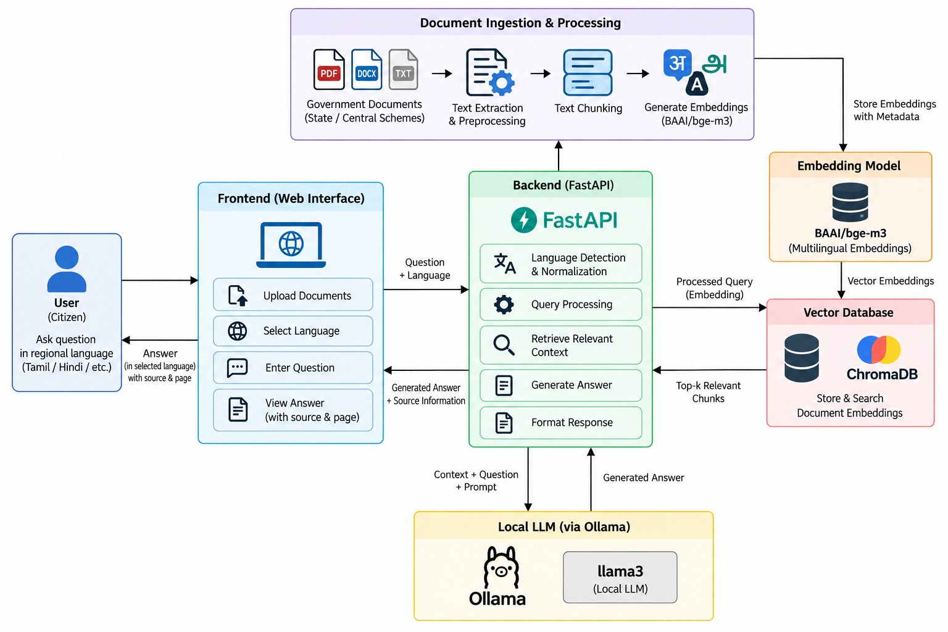
Figure 3.1 Architecture of the Proposed System

3.2 SYSTEM COMPONENTS

3.2.1 User Interface
The user interface is built using React and provides an interactive environment in which users can enter queries and view the generated answers.

3.2.2 Document Knowledge Base
The knowledge base consists of pre-loaded documents from which answers are constructed. These documents undergo text extraction, cleaning, normalisation and chunking, producing text segments that are ready for embedding and semantic retrieval.

3.2.3 Regional Language Processing
Before retrieval, each user query is processed using IndicNLP-based language processing, which prepares regional-language input for the subsequent stages while preserving the linguistic properties of Indian languages. Language detection and textual normalisation are performed at this stage.

3.2.4 Semantic Retrieval
The preprocessed query is embedded and compared against the document chunk embeddings stored in ChromaDB. Retrieval is based on similarity, and the chunks most semantically related to the query are returned.

3.2.5 Retrieval-Augmented Generation
The retrieved chunks form the knowledge context for the RAG pipeline. The user's query and the retrieved context are concatenated and passed to the language model so that the generated answer is based on the retrieved knowledge rather than solely on the model's pre-trained parameters.

3.2.6 LLM-Based Answer Generation
The concatenated prompt is sent to Llama 3 through Ollama. The model generates a natural-language answer from the prompt, which is then returned to the backend for delivery to the user.

3.2.7 Backend Services
The backend is implemented using FastAPI and acts as the communication medium between the frontend and the processing modules. It receives requests from React, coordinates preprocessing and data retrieval, communicates with the RAG and LLM modules, and returns responses to the frontend.

3.3 DOCUMENT PREPROCESSING AND CHUNKING

The system accepts PDF, TXT, and DOCX documents as knowledge sources. The uploaded document is first processed using the corresponding text extraction mechanism. For PDF documents, page information is retained whenever it can be reliably obtained.

After text extraction, IndicNLP-based normalization is applied to Indian regional-language content. This normalization stage standardizes Unicode-based Indic text and prepares it for subsequent processing. The normalized content is then divided into smaller retrievable chunks.

Let the document collection be represented as:

$$D=\left\{d_{1} , d_{2} , . , ..d_{N}\right\}$$

The processed documents are divided into chunks:

$$C=\left\{c_{1} , c_{2} , . , ..c_{m}\right\}$$

where $c_{j}$represents a retrievable portion of a source document.

Each chunk is associated with available metadata such as:

Source document name

Page number (when available)

Chunk identifier

The resulting chunks are then passed to the BAAI/bge-m3 embedding stage.

The preprocessing pipeline operates on the characters obtained from the document extraction stage. Therefore, the quality of the extracted text directly affects all subsequent stages, including normalization, embedding, retrieval, and response generation.

3.4 QUERY PROCESSING AND EMBEDDING GENERATION
After When the user submits a question $Q$, the query is processed according to the selected language. IndicNLP-based normalization is applied to prepare Indian regional-language input for semantic representation.
The normalized query is represented as:
$$Q^{'}=\text{IndicNLP}\text{_}\text{Normalize}\left(Q\right)$$
The normalized query is then converted into a dense multilingual embedding using BAAI/bge-m3:
$$q=E\left(Q^{'}\right)$$
Similarly, each document chunk $c_{j}$is represented as:
$$v_{j}=E\left(c_{j}\right)$$
where $E\left(⋅\right)$represents the BAAI/bge-m3 embedding function, $q$is the query vector, and $v_{j}$is the vector representation of the $j$-th document chunk.
Both the query and document chunks are represented in a multilingual semantic space, enabling retrieval of semantically related content even when the query wording does not exactly match the document text.
The generated query embedding is then supplied to the ChromaDB semantic retrieval stage.
3.5 VECTOR INDEXING AND SEMANTIC RETRIEVAL
The chunk vectors vj are stored and indexed in ChromaDB. When a query embedding q is received, the similarity between q and each stored chunk vector vj is computed using cosine similarity:
S(q, vj) = (q · vj) / (‖q‖ ‖vj‖)
The top-k relevant chunks Rk are then retrieved by selecting the chunks with the highest similarity scores:
Rk = arg max_{j ∈ {1,…,m}}^{k} S(q, vj)

3.6 CONTEXT AUGMENTATION AND RESPONSE GENERATION
The selected chunks Rk are concatenated with the user's normalised query Q′ to form an enhanced prompt P:
P = PromptFormat(Q′, Rk)
This prompt P is supplied to a local LLM available through Ollama, which produces the final response A:
A = LLM_Ollama(P)
The FastAPI backend then returns the response A to the React frontend for display to the user.

CHAPTER 4

PROJECT DESCRIPTION

4.1 INTRODUCTION
This chapter describes the various modules of the proposed Regional Language Question Answering System. The system is divided into multiple functional modules to ensure efficient handling of document processing, regional language understanding, semantic retrieval, and response generation. Each module performs a specific task, and together they contribute to the overall functionality and performance of the system.

4.2 DOCUMENT PROCESSING MODULE
The Document Collection and Preprocessing Module manages PDF, TXT, and DOCX documents used as knowledge sources. Users can either select available documents or upload their own documents through the frontend interface.
The uploaded document is processed to extract its available textual content. For PDF documents, page information is retained whenever it can be reliably obtained. Following extraction, IndicNLP-based normalization is applied to supported Indian-language Unicode text.
The normalized content is then prepared for subsequent chunking and embedding, while relevant document metadata is preserved for later source attribution.
The quality of the extracted text plays a critical role in the effectiveness of downstream stages in the pipeline. Documents containing scanned images or incorrectly encoded legacy-font text may not yield usable Unicode text through standard extraction methods. Such cases require Optical Character Recognition (OCR) or dedicated legacy-font conversion techniques, which are beyond the scope of the current implementation.
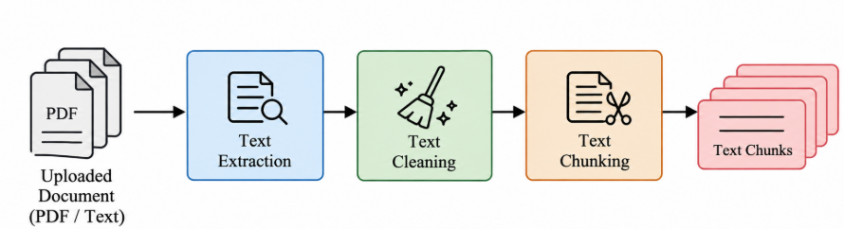
Figure 4.1 Document Processing Module

4.3 LANGUAGE PROCESSING AND NORMALIZATION MODULE
The Language Processing and Normalization Module prepares Indian-language document text and user queries for subsequent semantic processing. IndicNLP is used to normalize supported Indian-language Unicode text after document extraction and before query embedding.
The normalization process helps standardize textual representations and prepares the content for multilingual embedding generation. The module operates on the text obtained from the document extraction stage and does not perform optical character recognition (OCR) or legacy font conversion.
For user queries, the selected language is retained, and the query is normalized prior to conversion into a multilingual embedding using BAAI/bge-m3.
Thus, this module functions as the language normalization layer between text extraction or query input and the semantic embedding process.
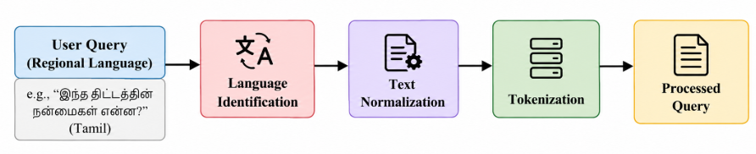
Figure 4.2 Language Processing and Normalization Module

4. 4 EMBEDDING AND VECTOR STORAGE MODULE
The embedding and vector storage module converts the processed document chunks and user queries into dense vector representations. These embeddings capture the semantic meaning of the text, enabling context-based matching instead of simple keyword search.
The generated embeddings are stored in a vector database, which acts as the system’s knowledge base. Efficient indexing and storage of embeddings allow fast and accurate retrieval of relevant information during query processing.

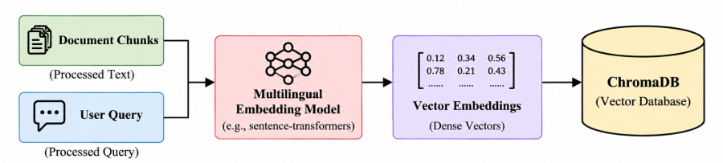
Figure 4.3 Embedding and Vector Storage Module

4. 5 SEMANTIC RETRIEVAL MODULE
The semantic retrieval module is responsible for identifying relevant document content based on the user query. The query is converted into an embedding and compared with stored document embeddings using similarity measures.
The system retrieves the most relevant document chunks based on similarity scores. This ensures that the information used for generating responses is contextually appropriate and aligned with the user’s query.
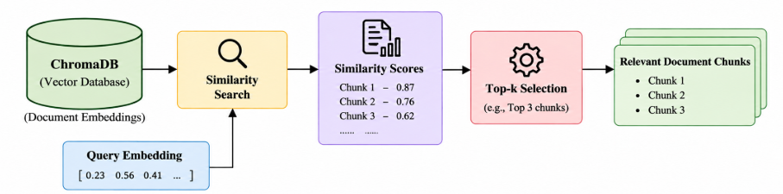
Figure 4.4 Semantic retrieval Module

4. 6 RESPONSE GENERATION MODULE
The response generation module generates answers using the retrieved document content. The system combines the user query with the retrieved information to form a contextual input for answer generation.
The generated response is based on actual document data, ensuring accuracy and reducing incorrect outputs. This module plays a crucial role in delivering meaningful and reliable answers to the user.
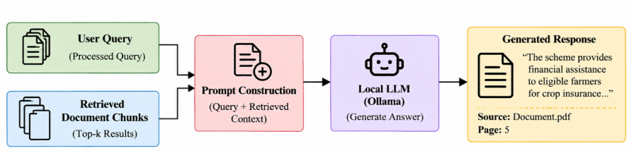
Figure 4.5 Response Generation Module

4. 7 USER INTERFACE MODULE
The user interface module provides interaction between the user and the system. It allows users to upload documents, select language preferences, and submit queries. The interface is designed to be simple and user-friendly to support users from different language backgrounds.
The module displays the generated answers along with relevant document references, enabling users to verify the information. It enhances usability and improves the overall user experience.

4.8 SUMMARY

This chapter described the six functional modules of the DesiQuery system. The Document Collection and Preprocessing Module prepares uploaded and selected documents for retrieval, while the Language Processing and Normalization Module prepares multilingual queries for semantic representation.

The Document Chunking and BGE-M3 Embedding Module converts document content into retrievable chunks and corresponding multilingual vector representations. The ChromaDB and Semantic Retrieval Module stores these representations and identifies relevant evidence using semantic similarity.

The RAG, Ollama, and Local LLM Module performs context selection and local response generation using Llama 3. Finally, the Source Document and Page Number Module maintains retrieval metadata and provides source traceability for generated responses.

The separation of these responsibilities results in a modular pipeline, enabling document processing, retrieval, generation, and source attribution to be developed and evaluated independently.

CHAPTER 5

IMPLEMENTATION AND RESULT ANALYSIS

5.1 INTRODUCTION

This chapter describes the implementation of the DesiQuery system and presents the results obtained from its evaluation. The application integrates document processing, multilingual question answering, semantic retrieval, Retrieval-Augmented Generation, and local language-model inference into a web-based system.

The system is implemented using React for the frontend and FastAPI for backend processing. BAAI/bge-m3 is used for multilingual embedding generation, ChromaDB is used for semantic vector retrieval, and Llama 3 through Ollama is used for local response generation. The application supports PDF, TXT, and DOCX documents and allows users to select documents before submitting questions in the supported languages.

The implemented interface provides separate facilities for managing documents, submitting questions, viewing generated responses, inspecting retrieved evidence, and analysing documents. Source-document, page, chunk, and similarity information are displayed when available to improve transparency and allow users to examine the evidence associated with an answer.

5.2 IMPLEMENTATION DETAILS

5.2.1 Dashboard Interface
The Dashboard provides the main entry point to the DesiQuery application. It gives users access to the major functions of the system, including document management, question answering, and document analysis.
The interface is designed as a centralized workspace from which users can navigate to the required functionality. The dashboard displays information obtained from the actual application state and backend services rather than using fabricated values.
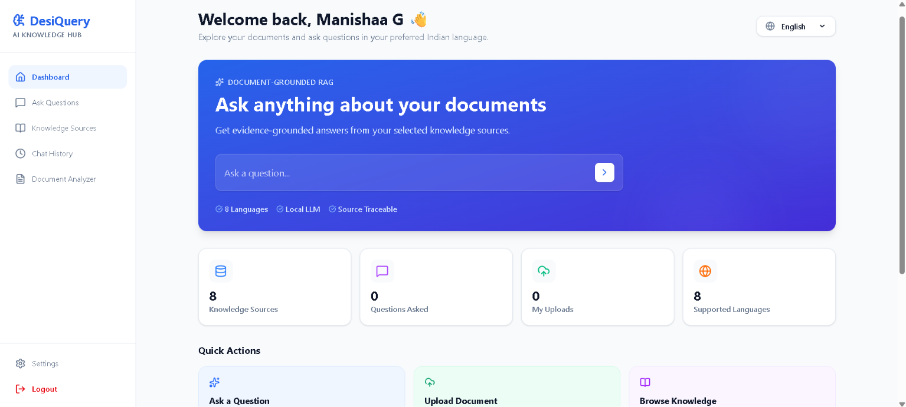
Figure 5.1: Dashboard Interface
5.2.2 Document Upload and Management
The Document Management interface allows users to work with the documents available to the QA system. Users can upload PDF, TXT, and DOCX files and select the documents that should be used as the knowledge source for a query.
During document processing, the system extracts the available textual content and divides it into smaller chunks. Metadata such as the document name and page information, when available, is retained with the corresponding chunks. The chunks are converted into multilingual embeddings using BAAI/bge-m3 and stored in ChromaDB for subsequent semantic retrieval.
The document selection mechanism ensures that question answering is performed using the documents selected by the user rather than an unrestricted document collection.

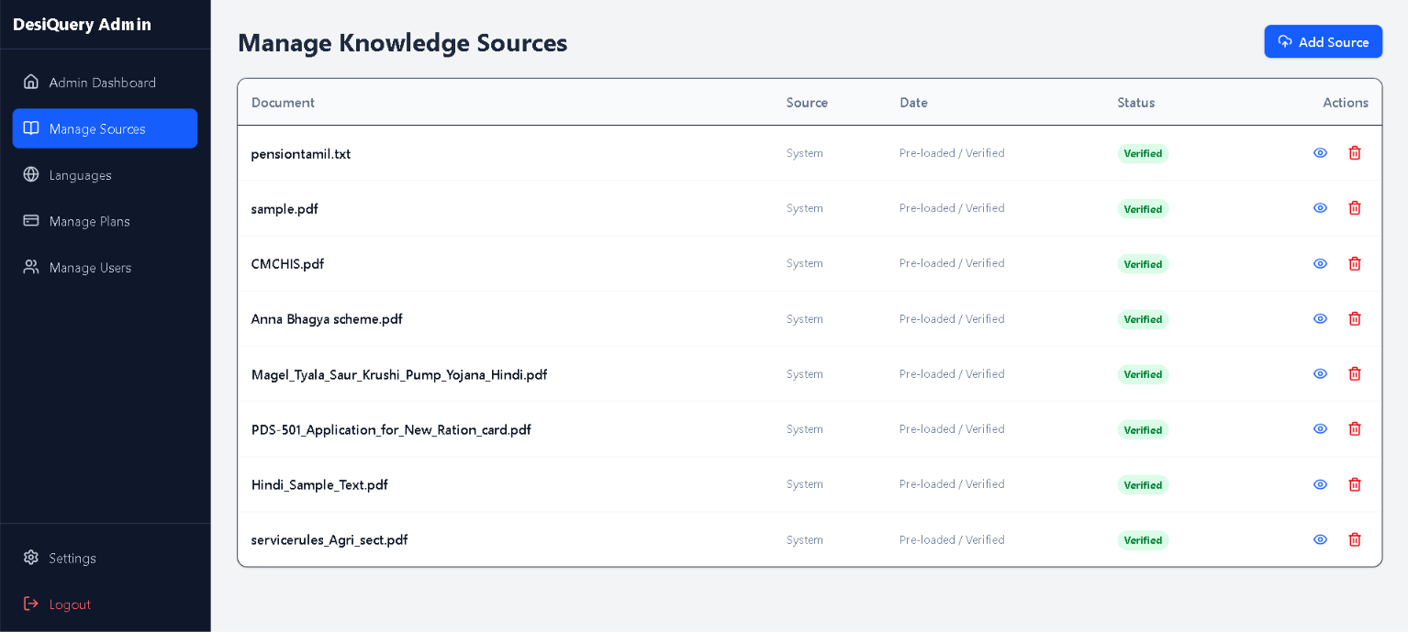
Figure 5.2: Document Upload and Management Interface
5.2.3 Multilingual Question Answering Interface
The Question Answering interface provides the main interaction between the user and the DesiQuery system. The user selects the required output language, selects the relevant document or documents, and enters a question.
When the question is submitted, the backend generates a multilingual representation of the query using BAAI/bge-m3. ChromaDB then identifies the document chunks with the highest semantic similarity to the query. The retrieved information is passed through the context-selection stage before being supplied to Llama 3 through Ollama.
The generated response is displayed in the selected output language. If the required information cannot be identified in the selected documents, the system indicates that the information is unavailable instead of generating an unsupported response.
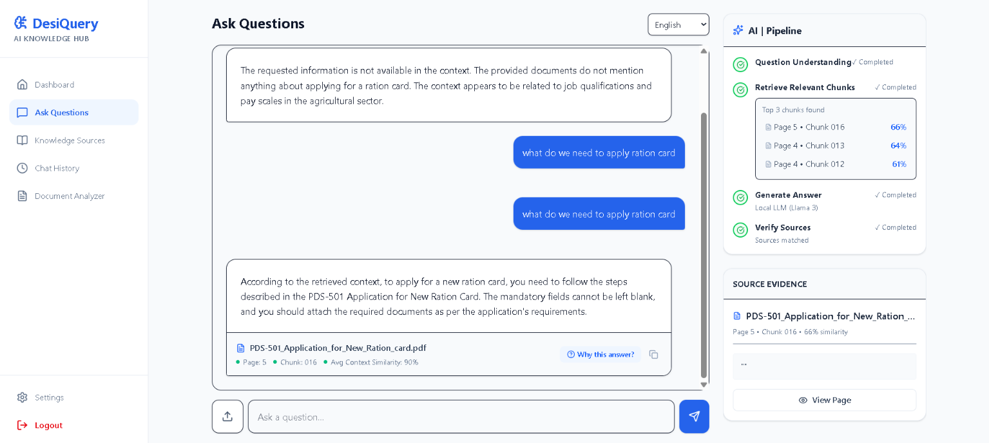
Figure 5.3: Multilingual Question Answering Interface
5.2.4 Answer and Source Attribution
The answer interface provides not only the generated response but also the available retrieval information associated with it. This feature is included to improve the transparency of document-grounded question answering.
For each retrieved item, the interface can display:
- Source document name
- Page number, when available
- Chunk identifier
- Retrieval similarity
- Retrieved chunk content
The similarity value represents the relevance of the retrieved content to the submitted query. It is presented as a retrieval similarity measure and is not treated as a probability or guaranteed confidence value.
The retrieved evidence can be inspected by the user to understand which document content was used during answer generation.
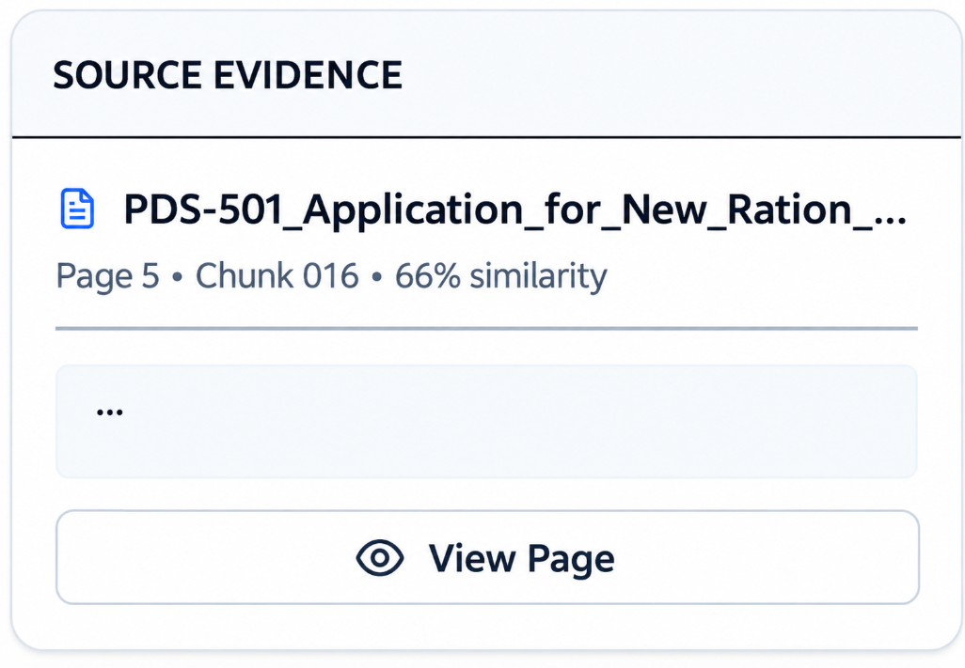
Figure 5.4: Generated Answer with Source Attribution
5.2.5 Retrieved Evidence and AI Pipeline
The QA interface also provides an evidence-oriented view of the retrieval and generation process. The AI pipeline presents the major processing stages involved in producing the response.
The pipeline includes question processing, relevant-chunk retrieval, response generation, and source verification. The retrieved evidence section provides the document and chunk information associated with the answer.
Only information returned by the backend is displayed. If page numbers, chunk identifiers, or similarity values are unavailable, the interface does not fabricate replacement values.
The evidence view is intended to help users inspect the relationship between the generated response and the source document content without exposing hidden model reasoning.

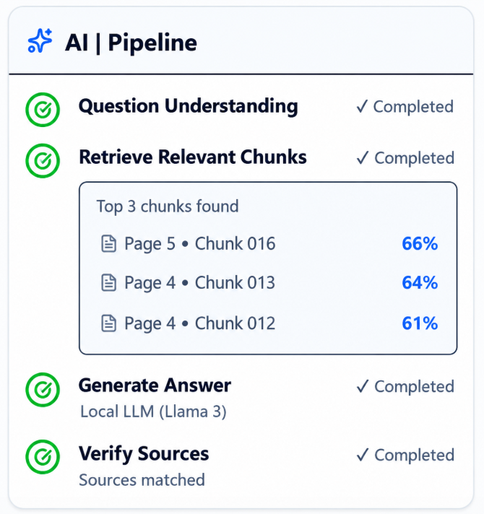
Figure 5.5: Retrieved Evidence and AI Pipeline
5.2.6 Document Analyzer
The Document Analyzer provides an interface for examining the processed document content. It allows users to inspect information extracted from the selected document and supports analysis of the document content used by the QA pipeline.
The analyzer is particularly useful for verifying whether the required information is actually present in the source document before submitting a question. This also helps users understand the document content associated with the retrieved evidence.
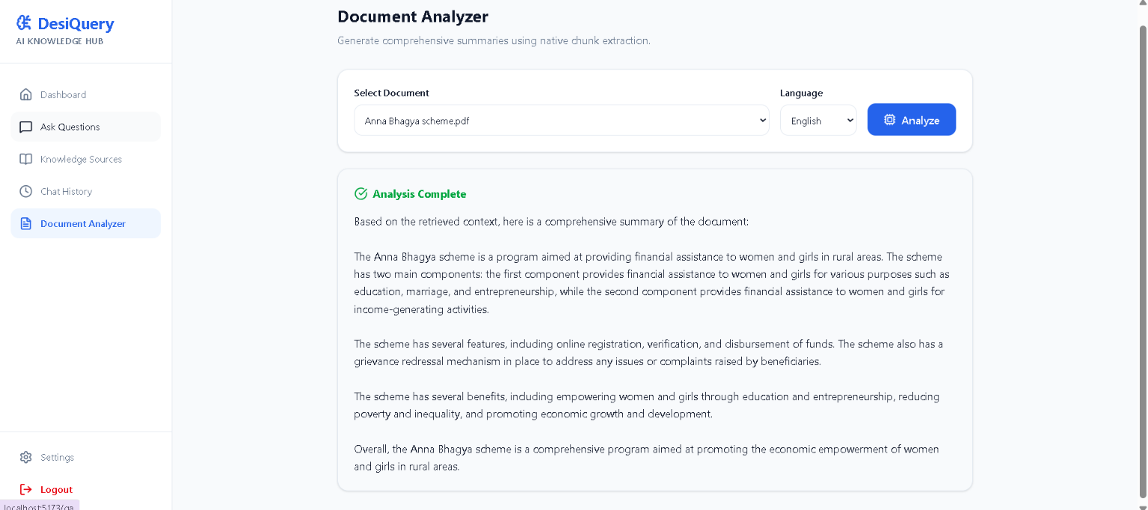
Figure 5.6: Document Analyzer Interface
5.2.7 Error Handling and Pipeline Diagnostics
The system provides explicit handling for different stages of the QA pipeline. Errors associated with document processing, retrieval, response generation, or source information are reported separately rather than being presented as successful responses.
Documents with insufficiently extractable content are rejected appropriately. Retrieval failures and local LLM generation failures are also reported to the user. Diagnostic information can be inspected during development to identify the stage responsible for a failure.
The system does not generate artificial source documents, page numbers, chunk identifiers, similarity values, or answers when the required information is unavailable.

5.3 SYSTEM EXECUTION
The execution of DesiQuery begins with document selection or upload. The selected documents are processed to extract their textual content. The extracted content is divided into chunks, and BAAI/bge-m3 generates multilingual embeddings for these chunks. The resulting embeddings and metadata are stored in ChromaDB.
The user then selects the required output language and submits a question through the Question Answering interface. The question is converted into an embedding and compared with the indexed document embeddings using semantic similarity.
The highest-ranked document chunks are retrieved from ChromaDB. The retrieved content then passes through a context-selection stage that retains relevant evidence and removes unnecessary or redundant content when required. The selected context is supplied to Llama 3 through Ollama for local response generation.
The generated response is returned to the frontend together with the available source metadata. The interface presents the answer along with the corresponding source document, page number, chunk identifier, retrieval similarity, and retrieved evidence when these values are available.
For questions where the requested information cannot be identified in the selected documents, the system reports that the information is unavailable rather than relying on information outside the retrieved evidence.
The complete execution flow can therefore be represented as:
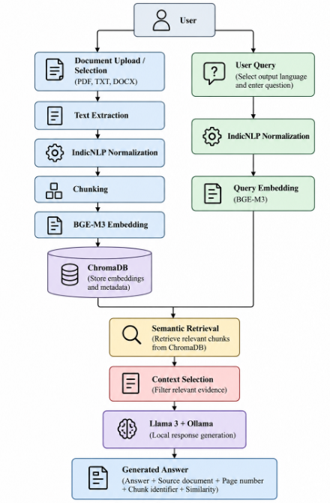
Figure 5.7: System Execution Flow
5.4 RESULT ANALYSIS
The implemented system was evaluated using 24 test cases across the eight supported languages: English, Tamil, Hindi, Telugu, Kannada, Malayalam, Bengali, and Marathi.
Three types of questions were included:
- Procedure-based questions
- Application/document-related questions
- Unsupported questions
Each category contained one test case for each of the eight languages.
The evaluation produced 19 PASS, 5 WARNING, and 0 FAIL cases.
TABLE 5.1 OVERALL EVALUATION RESULTS
Evaluation Measure | Result
Total test cases | 24
PASS | 19 (79.2%)
WARNING | 5 (20.8%)
FAIL | 0 (0%)
Language validation | 100%
Grounding validation | 100%
Source traceability | 100%
Average response time | ≈102 seconds

Language validation achieved 100% across the evaluated test cases, indicating that the generated responses followed the selected output language according to the implemented validation procedure.
Grounding validation also achieved 100% for the evaluated test set. The evaluation verified whether relevant claims, numerical information, and procedural content could be supported by the retrieved document evidence. This
result represents grounding validation for the evaluated cases and should not be interpreted as general factual accuracy.
Source traceability achieved 100% across the evaluated cases. The system retained the source document and, when available, page number, chunk identifier, retrieval similarity, and retrieved content.
The five WARNING cases were associated with response-completeness limitations in some multilingual outputs. No evaluated case was classified as a FAIL.
The average end-to-end response time was approximately 102 seconds under the tested local hardware and configuration. Local LLM generation contributed most of the observed latency, whereas semantic retrieval generally required substantially less time.
TABLE 5.2 LANGUAGE-WISE EVALUATION RESULTS
Language | PASS | WARNING | FAIL
English | 3 | 0 | 0
Tamil | 3 | 0 | 0
Hindi | 3 | 0 | 0
Telugu | 1 | 2 | 0
Kannada | 2 | 1 | 0
Malayalam | 1 | 2 | 0
Bengali | 3 | 0 | 0
Marathi | 3 | 0 | 0
Total | 19 | 5 | 0

The results show that all evaluated languages satisfied the language-validation requirement. The warning cases occurred in Telugu, Kannada, and Malayalam and were associated with response completeness rather than grounding or source-traceability failure.

5.5 DISCUSSION
The implemented DesiQuery system demonstrates the feasibility of document-grounded question answering across the eight supported Indian languages under the evaluated configuration. The use of BAAI/bge-m3 enables multilingual semantic representation, while ChromaDB provides local similarity-based retrieval of relevant document content.
The context-selection stage further limits the information supplied to the language model by retaining relevant retrieved content and reducing unnecessary context. This is useful for local inference because it controls the amount of information supplied to Llama 3 during generation.
The source-traceability mechanism provides additional transparency by associating generated responses with retrieved document information. Users can inspect the source document, page number, chunk identifier, similarity value, and retrieved content when these values are available.
The evaluation achieved complete validation for language consistency, grounding, and source traceability across the tested cases. However, five warning cases indicate that response completeness remains an area for improvement for some multilingual outputs.
Response latency is another limitation of the current implementation. Local Llama 3 inference contributes substantially to the total processing time. The measured latency is dependent on the available hardware, model configuration, context size, and generated output length.
The evaluation is based on a relatively small set of 24 test cases. Therefore, the results characterize the implemented system under the tested conditions and should not be interpreted as generalized performance across all regional-language questions and document collections.

5.6 SUMMARY

This chapter presented the implementation and result analysis of the DesiQuery system. The application integrates document processing, multilingual semantic representation using BAAI/bge-m3, vector retrieval using ChromaDB, context selection, and local response generation using Llama 3 through Ollama.

The implemented interface provides document management, multilingual question answering, source attribution, retrieved-evidence inspection, document analysis, and pipeline diagnostics. The QA interface displays available source-document, page, chunk, and similarity information to improve evidence traceability.

The system was evaluated using 24 test cases across eight languages and three question categories. The evaluation resulted in 19 PASS, 5 WARNING, and 0 FAIL cases, with 100% language validation, 100% grounding validation, and 100% source traceability for the evaluated test set.

The evaluation also identified response completeness and local LLM inference latency as areas requiring further improvement. These findings provide the basis for the future development and optimization discussed in the following chapter.

CHAPTER 6

CONCLUSION AND FUTURE WORK

6.1 CONCLUSION

DesiQuery was developed as a document-grounded multilingual Question Answering system for accessing information from documents in Indian regional languages. The system integrates document processing, multilingual semantic representation, vector-based retrieval, context selection, and local Large Language Model generation into a single application.

The implemented system uses BAAI/bge-m3 to generate multilingual embeddings, ChromaDB for semantic retrieval, and Llama 3 through Ollama for local response generation. The application supports PDF, TXT, and DOCX documents and enables users to select the documents from which information should be retrieved. This document-selection mechanism helps restrict the question-answering process to the intended knowledge sources.

The system supports eight languages: English, Tamil, Hindi, Telugu, Kannada, Malayalam, Bengali, and Marathi. Questions are processed using multilingual semantic retrieval, and the generated response is produced according to the selected output language. The response-generation process is constrained using the retrieved document evidence so that information unavailable in the selected documents is not intentionally generated from external model knowledge.

A major feature of the system is source traceability. Along with the generated answer, the application provides available source-document information, page number, chunk identifier, retrieval similarity, and retrieved evidence. This allows users to inspect the document content associated with an answer and provides greater transparency than presenting a generated response alone.

The system was evaluated using 24 test cases covering three categories of questions across the eight supported languages. The evaluation produced 19 PASS cases, 5 WARNING cases, and 0 FAIL cases. Language validation, grounding validation, and source traceability achieved 100% validation across the evaluated test set. The evaluation also showed that local LLM generation is the primary contributor to the observed response latency.

The warning cases indicate that response completeness can still be improved for certain multilingual responses. In addition, the relatively small evaluation dataset and dependence on local hardware limit the extent to which the reported results can be generalized to larger document collections and broader language use cases.

Overall, the developed system demonstrates the feasibility of combining multilingual semantic retrieval with locally deployed LLM-based generation for document-grounded question answering. The integration of retrieval evidence and source metadata provides a practical approach for improving transparency while maintaining a fully local QA pipeline.

6.2 FUTURE WORK

Although the current implementation provides the required multilingual document-grounded QA functionality, several improvements can be considered for future development.

6.2.1 Expansion of Evaluation Dataset

The current evaluation contains 24 test cases. Future work can develop a larger benchmark containing a greater number of questions, documents, query types, and difficulty levels for each supported language. This would provide a more comprehensive evaluation of retrieval and generation performance.

6.2.2 Improved Regional-Language Evaluation

Future versions can introduce language-specific evaluation datasets and evaluation criteria for Tamil, Hindi, Telugu, Kannada, Malayalam, Bengali, Marathi, and other Indian languages. This can help identify language-specific retrieval and response-generation limitations.

6.2.3 Improved Retrieval Techniques

The retrieval component can be further enhanced by investigating alternative retrieval strategies such as hybrid lexical-semantic retrieval, improved ranking methods, and adaptive retrieval depth. These approaches can be evaluated against the current BAAI/bge-m3 and ChromaDB configuration.

6.2.4 Optimization of Local LLM Inference

Local LLM generation currently contributes substantially to the overall response latency. Future work can investigate quantized models, optimized inference configurations, smaller language models, and hardware acceleration to reduce response time while maintaining acceptable response quality.

6.2.5 Improved Document Processing

Future development can extend document processing to handle scanned PDFs, tables, images, multi-column layouts, and other complex document structures. Optical Character Recognition (OCR) can be incorporated for image-based documents where reliable text extraction is not possible.

6.2.6 Advanced Context Selection

The context-selection stage can be further improved using adaptive chunk selection and relevance filtering. The number and size of retrieved chunks can be adjusted according to the query and document content to reduce unnecessary context while preserving relevant evidence.

6.2.7 Enhanced Source Traceability

Future versions can provide more detailed evidence visualization, including highlighted source passages, page-level navigation, and direct access to the relevant section of the source document. This can make it easier for users to verify generated responses against the original document.

6.2.8 Larger Language Coverage

The framework can be extended to additional Indian regional languages as suitable multilingual embedding and language-generation models become available. This would increase the applicability of the system to a broader range of users and document collections.

6.2.9 Improved Document and Knowledge Management

Future versions can provide enhanced document organization, document version management, collection-based retrieval, and improved search and filtering facilities. These features can be useful when the system contains a larger number of documents.

6.2.10 Comprehensive Performance Evaluation

Future work can conduct detailed experiments involving retrieval accuracy, context-selection effectiveness, response completeness, latency, and resource consumption. Ablation studies can also be performed to measure the individual contribution of multilingual embeddings, retrieval depth, context filtering, and local LLM generation.

6.2.11 Future Deployment Possibilities

The current system is designed around local processing without dependence on cloud-based LLM APIs. Future development can investigate optimized deployment on institutional servers or other controlled computing environments while retaining the privacy and source-control characteristics of the local architecture.

REFERENCES
1. S. Amal, A. R. Niranjan and M. G. Thushara (2026) 'EduRAG: A Multimodal Explainable RAG System with Deterministic Token Grounding'.
2. M. Ali, R. Speck, H. M. Zahera, M. Saleem, D. Moussallem and A.-C. N. Ngomo (2025) 'Multilingual Relation Extraction: A Survey', IEEE Access.
3. S. Behmanesh, A. Talebpour, M. Shamsfard and M. M. Jafari (2024) 'A Novel Open-Domain Question Answering System on Curated and Extracted Knowledge Bases with Consideration of Confidence Scores in Existing Triples'.
4. J. Choi, S. Hong, S. Hong, J. Park and E.-S. Jung (2025) 'Toward Generating Quality Test Questions and Answers Using Quantized Low-Rank Adapters in LLMs'.
5. M. L. L. de Oliveira and J. de Jesus Fiais Cerqueira (2026) 'Resource-Constrained Evaluation of Quantized Local LLMs for Retrieval-Augmented Generation on a Reduced-Corpus Setting', IEEE Access.
6. M. Nadas, L. Diosan and A. Tomescu (2025) 'Synthetic Data Generation Using Large Language Models: Advances in Text and Code', IEEE Access.
7. J. Fields, K. Chovanec and P. Madiraju (2024) 'A Survey of Text Classification with Transformers: How Wide? How Large? How Long? How Accurate? How Expensive? How Safe?'
8. K. A. Hambarde and H. Proença (2023) 'Information Retrieval: Recent Advances and Beyond'.
9. M. Hindi, L. Mohammed, O. Maaz and A. Alwarafy (2025) 'Enhancing the Precision and Interpretability of Retrieval-Augmented Generation (RAG) in Legal Technology: A Survey', IEEE Access.
10. S. Huang and T. Su (2025) 'TransAlignNet: Semantic Consistency Learning with Multi-Modal Attention for English Translation Inference'.
11. F. F. Ijebu, Y. Liu, C. Sun, N. Jere, I. D. Mienye and P. U. Usip (2025) 'Ensemble Answer Selection Leveraging Cross-Lingual Dealignment for Improved QA with Mixture-of-Experts Setup'.
12. Z. Hu, P. Yang, F. Liu, Y. Meng and X. Liu (2024) 'Prompting Large Language Models with Knowledge-Injection for Knowledge-Based Visual Question Answering', Big Data Mining and Analytics, Vol.7, No.3.
13. T. F. Khan, M. Arslan, F. Alturise, A. H. Almutairi and M. T. Raza (2026) 'UQA-RAG: Enhancing Urdu Question-Answer Retrieval with Semantic Similarity and LLMs'.
14. L. Kong, X. Zhong, J. Chen, H. Fu and Y. Wang (2025) 'Multi-Perspective Consistency Checking for Large Language Model Hallucination Detection: A Black-Box Zero-Resource Approach', Frontiers of Information Technology & Electronic Engineering.
15. P.-J. Liao, H.-Y. Lee and H.-M. Wang (2026) 'Cross-Attention Reprogramming for ASR: Bridging Discrete Speech Units and Pretrained Language Models'.
16. A. Onan, A. H. Nasution, T. Celikten and P. Cetin (2026) 'Comparing ChatGPT, Gemini, and Emerging LLMs in Low-Resource Educational Settings: Reasoning Quality, Consistency, and Explainability', IEEE Access.
17. A. Perevalov, A. Gashkov, M. Eltsova and A. Both (2025) 'SPARQL Query Candidate Filtering for Improving the Quality of Multilingual Question Answering over Knowledge Graphs Using Language Models', Journal of Web Engineering, Vol.24.
18. B. Saha, U. Saha and M. Z. Malik (2024) 'QuIM-RAG: Advancing Retrieval-Augmented Generation with Inverted Question Matching for Enhanced QA Performance', IEEE Access, Vol.12.
19. A. V. A. Sinthusha, E. Y. A. Charles and R. Weerasinghe (2025) 'Machine Reading Comprehension for the Tamil Language with Translated SQuAD'.
20. J. Xu, H. Zhang, H. Zhang, J. Lu and G. Xiao (2024) 'ChatTF: A Knowledge Graph-Enhanced Intelligent Q&A System for Mitigating Factuality Hallucinations in Traditional Folklore', IEEE Access, Vol.12.

